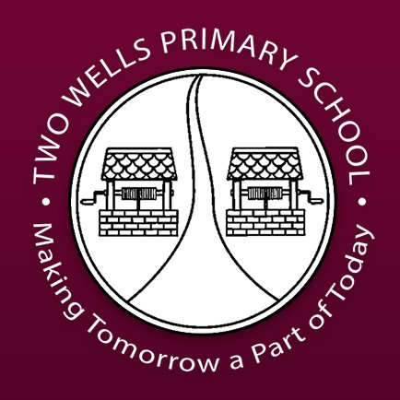
Two Wells Primary School Uniform Policy

In 1993 State Government gave Governing Councils the power to determine policy on School Dress within their schools.

Vision
  - All students will wear the designated school uniform with pride.
  - School morale will be maintained.
  - Peer pressure on students to compete will be limited.

School Dress Code

The school colours:
Reception to Year 5 - a maroon t-shirt and black pants, leggings or a skirt.
Year 6 – a grey t-shirt and black pants, leggings or a skirt.

Hats:
- A sun safe hat is required when outdoors all year round as per our Sun safe policy.

Footwear:
- Enclosed footwear will qualify as acceptable footwear. Students need to be able to safely participate in physical activity.

Jewellery:
- Body piercings, with the exception of ears, are not acceptable for safety reasons.
- Acceptable jewellery for school is a watch and small sleepers/studs in ears. No other jewellery is to be worn at school.

Hair & Makeup:
- Except on special occasions e.g. sports day, brightly coloured hair (pink, blue, purple etc.) is not acceptable for school.
- Make–up including nail varnish/false nails for students is not acceptable at school. Spray deodorants are also not acceptable at school (as per DfE WHS regulations).

Other requirements:
- No specific brand of clothing is required however clothing bearing large logos/motifs is unacceptable.
- The school logo should be used whenever possible (available for purchase from the Uniform Shop).
- Items of clothing should ensure students safety and must not restrict movement or participation in school activities.
- Shorts, leggings or skirts should not restrict movement, and should be of a reasonable length (mid-thigh to knee). The fabric should not be transparent.
- Tank tops, crop tops, midriff tops and hooded tops are unacceptable.
- It is essential that students clothing is marked with their name to enable easy identification. Unclaimed, unnamed lost clothing is washed and sold as second hand items at the end of each term.

Communication:

- This policy will be communicated to parents/caregivers and students through enrolment interviews, Skoolzine app, assembly, class meetings and Student Action Team.

Exemption from Dress Code:

- Parents/caregivers may be able to make a written request for exemption from Dress Code and School Uniform Policy according to the following grounds specified by DfE:
  - Cultural or ethnic
  - New student (need time to purchase)
  - Itinerant students
  - Any other grounds Governing Council may determine.

Non Compliance with Dress Code:

- Parents/caregivers will be informed by the class teacher via diary and dojo messages, a follow up phone call may be required for persistent non-compliance.
- Leadership and class teachers will regularly monitor our School Uniform Policy.
- Teachers and staff may send persistent non-compliant students to the front office to arrange for a parent/caregiver to bring in school uniform.
- The Principal will arrange a meeting with parents/caregivers to discuss uniform expectations. Wearing our uniform is part of the expectations of our school following an enrolment interview. Where appropriate, we may provide support to the family.

School Uniform:

- Uniform can be purchased through the school office.

Review:

- Governing Council will review the School uniform policy on an annual basis
- A Governing Council committee will be established to ensure a consultation process is instigated in the event that a change to the uniform is required.

